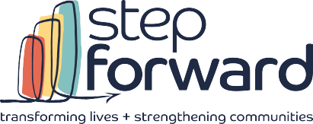1801 superior avenue

suite 400

cleveland, oh 44114

t. 216.696.9077

f. 216.696.0770

Stepforwardtoday.org

April 2, 2025

Dear Legislator,

Throughout Ohio and in your district, Head Start is making a real difference. Step Forward provides childcare and preschool services so that more than 1,700 children and their families have the chance to work, learn and grow. Yesterday, the administration closed five regional offices, including the Region 5 Office of Head Start that oversees operations in six states including Ohio.

The children we serve are at or below the federal poverty level, are experiencing homelessness, live in foster care or kinship care, and/or have disabilities.   Every Head Start program is locally controlled, driven by local needs and designed so parents have the support they need to go to work or school, knowing their child is in a safe, nurturing educational environment.

Head Start strengthens our local economy. Step Forward’s Head Start employs 240 dedicated staff members and invests nearly $8 million in services with businesses and community partners. The support parents receive from Head Start allows them to work, pursue education and job training and provide for their families. A majority of the parents we currently serve are working or in job training. The attached flyer goes into greater detail about Head Start’s impact and return on investment.

The closure of the Region Five Office of Head Start will have a significant impact on our state and community, as this office provided essential support for our federal grants. Without regional staff to process funding, delays could jeopardize our ability to continue services. Additionally, the loss of technical assistance puts child health and safety at risk.

This move appears to be a deliberate effort to weaken early childhood programs by reducing the staff who work directly with Head Start grantees. The result? Disruptions to critical services for children and families—and a complete lack of transparency about what comes next.

We welcome the chance to visit our program, meet our staff and families and talk with community leaders to learn more about Head Start’s impact in your district.

Thank you for your support for early childhood education and families in our community. We will keep you posted about the impact of the Regional Office closure on services in your district.

Sincerely,