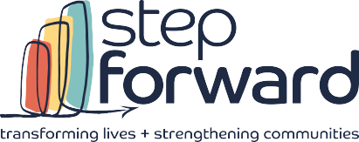
1801 superior avenue
suite 400
cleveland, oh 44114
t. 216.696.9077
f. 216.696.0770

stepforwardtoday.org

Dear Legislator,

I am writing to urge your immediate support for the Community Services Block Grant (CSBG), which is essential for Community Action Agencies (CAAs) across Cuyahoga County and Ohio. CSBG is critical for reducing poverty, promoting self-sufficiency, and revitalizing communities.

In FY2024, Step Forward received Community Services Block Grant (CSBG) funding, which enabled us to provide vital services to local families. With this support, Step Forward was able to:

• Assist with emergency support such as food and clothing vouchers, rental assistance, and other critical resources.
• Provide job training and employment services to help individuals secure stable work.
• Offer community outreach, including services for pregnant mothers, prenatal care, newborn resources, and counseling.

These programs are essential for helping families in Cuyahoga County achieve stability and self-sufficiency, especially in times of crisis.

Representatives Jim Costa (D-CA-21) and Brian Fitzpatrick (R-PA-01) are circulating a bipartisan letter in the U.S. House of Representatives requesting $780 million for FY2026 CSBG funding, as well as ensuring CAAs can serve households with incomes up to 200% of the poverty line. This funding is crucial for continuing our work and meeting the needs of our community.

I urge you to support this critical funding request. By doing so, you will directly help thousands of families in Cuyahoga County access vital resources and services that empower them to build stable, self-sufficient futures.

I would also invite you to visit Step Forward to meet our dedicated staff, speak with families we serve, and see firsthand how CSBG funding transforms lives in your district.

Thank you for your time, consideration, and commitment to supporting CSBG. Your leadership can make a lasting difference in the lives of those who need it most.

Sincerely,

